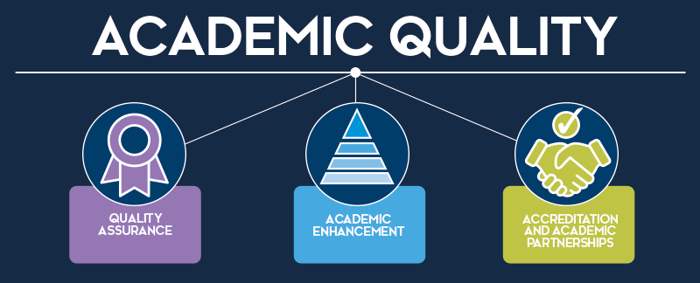
Partner Annual Monitoring and Review Policy
Quality Assurance Policy

Purpose

This policy outlines and define the roles, responsibilities and timelines associated with the Partner Annual Monitoring and Review (PAMR) process.

The UK Quality Code for Higher Education identifies the following core expectations for quality and standards:
- ‘Where a provider works in partnership with other organisations it has in place effective arrangements to ensure that the standards of its awards are credible and secure irrespective of where or how courses are delivered or who delivers them’
- ‘Where a provider works in partnership with other organisations it has in place effective arrangements to ensure that the academic experience is high quality irrespective of where or how courses are delivered or who delivers them’

This policy has been developed after careful consideration of the UK Quality Code for Higher Education and is designed to ensure the University complies and excels with these core practices.

A glossary, defining terms used in this document, can be found in Appendix 1.

Scope

This policy applies to Heriot-Watt University and its Delivery Partners, Approved Learning Partners and Joint Collaborative Partners.

1. Introduction

1.1 The University has an extensive network of academic partners who deliver academic programmes to students. Such activities are considered 'high risk' as there may be issues arising which may impact on the student learning experience, and which are outside the University's direct control.

1.2 Partner Annual Monitoring and Review forms part of the University’s wider Annual Monitoring Review process, aiming primarily to monitor and review the academic quality and standards of existing partnerships. The review also aims to identify areas for enhancement, drive improvements to the student learning experience and ensure contract compliance and reflect on the business viability of the partnership.

1.3 Partner Annual Monitoring and Review is a contractual requirement for all Delivery Partners, Approved Learning Partners and Joint Collaborative Partners of Heriot-Watt University where active students were present in the previous academic year (the reporting period). This includes any academic partnerships in the process of termination, whereby a programme is on ‘teach out’ and students remain on a programme until their studies are complete.

1.4 The Quality and Academic Partnerships Manager has overall management oversight of the Partner Annual Monitoring and Review process. The Partnerships Support Manager has responsibility for the management and operation of the Partner Annual Monitoring and Review (PAMR) process, ensuring its completion on an annual basis.

1.5 A diagram demonstrating the main steps of the PAMR process can be found in Appendix 2. A full list of the roles and responsibilities of staff involved in the PAMR process are listed in Appendix 3 and a timeline of the PAMR process is detailed in Appendix 4.
2. Completion and Submission of PAMR Forms

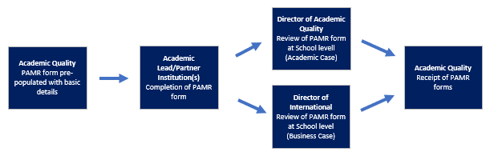
2.1 The process for the completion and submission of PAMR forms is highlighted in the diagram below:
*Role descriptors in the above diagram have been updated as follows:
Director of Academic Quality: now Associate Executive Dean (Academic Quality)
Director of International: now Associate Executive Dean (International)

2.2 A separate PAMR form should be completed for each partner institution or group of partner institutions, where a legal agreement relates to multiple academic partners. Where more than one legal agreement is held with a partner institution, one form should be completed per programme or group of programmes. Where Heriot-Watt University is the lead institution, the Heriot-Watt University PAMR form template should be used. Where the academic partner is the lead institution, the partner’s template may be used but will provide the same information and level of detail as noted in the Heriot-Watt University template.

2.3 The PAMR form should consider student recruitment and admissions, progression and awards, resources and facilities, academic and support issues, student feedback, partner relations, graduate employment, areas of good practice and recommendations for any actions, as appropriate to the partnership. The PAMR form should provide an evaluation of the relationship with the partner, together with feedback on the partnership from an operational and strategic perspective.

2.4 Academic Quality are responsible for pre-populating each PAMR form with key details in relation to the partnership including partner institution(s) name; partner institution(s) address; contact details for both HWU and the partner institution(s); programme code/title; approval status and reporting period. Any actions highlighted in preceding PAMR exercises will be pre- populated by Academic Quality to allow an update on the progress/status of actions to be provided.

2.5 The Academic Lead and partner institution are jointly responsible for ensuring the PAMR form is completed with appropriate consultation from support staff such as teaching staff and professional services staff. The Academic Lead and partner institution should reflect on the previous academic year regarding areas of good practice and areas for enhancement and provide detailed and comprehensive responses to questions. Examples of how to complete the PAMR form can be found in Appendix 5.

2.6 The Associate Executive Dean (International) is responsible for reviewing all PAMR forms from a business perspective to consider the business viability of the partnership and identify any potential areas for growth or expansion.

2.7 The Associate Executive Dean (Academic Quality) is responsible for ensuring all PAMR forms are completed to an appropriate standard, with sufficient detail, and any issues identified have been suitably actioned. The Associate Executive Dean (Academic Quality) should aim to identify any common themes and good practice regarding the operation of partnerships across the School. The Associate Executive Dean (Academic Quality) is responsible for ensuring all PAMR forms are submitted to Academic Quality in a timely manner, before the relevant submission deadline (as confirmed in each reporting period – normally the end of May in the given monitoring period).
3. Institutional Review of PAMR Forms

3.1 The process for the institutional review of PAMR forms is highlighted in the diagram below:
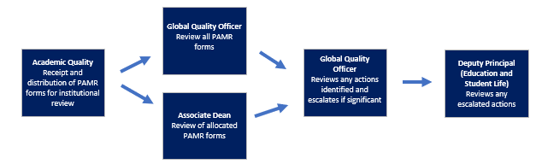
*Role descriptors in the above diagram have been updated as follows:
Global Quality Officer: now Partnerships Support Manager

3.2 The Partnerships Support Manager, Associate Deans and, in exceptional circumstances, the Deputy Principal (Education and Student Life) are responsible for reviewing PAMR forms from an institutional perspective.

3.3 Academic Quality are responsible for the distribution of PAMR forms to Associate Deans. An equal number of forms are allocated to each Associate Dean. Associate Deans cannot be allocated forms for partnerships operating in the School(s) to which they are assigned, to ensure the impartiality of the review. Forms are reviewed simultaneously by the Partnerships Support Manager and Associate Deans.

3.4 Associate Deans are responsible for reviewing a set allocation of PAMR forms for partnerships independent from their assigned School(s). Following a review of forms, the Associate Dean will make a judgement as to whether or not proper engagement in the process has been demonstrated, with appropriate monitoring and review taking place; all issues raised have been addressed (through actions or other acknowledgement) and if any issues need referred back to the School or escalated to the Deputy Principal (Education and Student Life). Associate Deans will summarise the findings of their review on the form provided.

3.5 The Partnerships Support Manager is responsible for reviewing all PAMR forms from an institutional quality assurance perspective with the purpose of identifying common School-level or University-level issues and highlighting areas of good practice. Operational process issues may also be highlighted. The Partnerships Support Manager, in conjunction with the Quality and Academic Partnerships Manger, will review all comments from Associate Deans and escalate PAMR forms where necessary.

3.6 Any major issues applicable to one specific partnership or a number of partnerships should be escalated to the Deputy Principal (Education and Student Life) by the Partnerships Support Manager. Examples of issues that may be escalated include, but are not limited to: high failure rates for programmes; concerns raised by a professional, regulatory or statutory body; failings in either the administrative or academic arrangements of a programme; evidence of concerns about assessment arrangements (for example, relating to marking standards or effectiveness of moderation); concerns regarding academic or professional services staffing; failings in standards that do not appear to have been rectified through normal processes; cohort size not sufficient to sustain quality of student experience or the Partner has repeatedly failed to provide the required monitoring information when due.

3.7 Action taken by the Deputy Principal (Education and Student Life) will vary depending on the nature and severity of the issues identified. Actions may include the development of a formal corrective action plan with specified actions, deadlines and monitoring; additional or immediate visits to the partner institution; or a temporary suspension of intake to the programme; and/or permanent termination of the partnership.

4. Reporting and Feedback

4.1 The process for the production of institutional reports and feedback to committees; external bodies; Schools and partner institutions is highlighted in the diagram below:
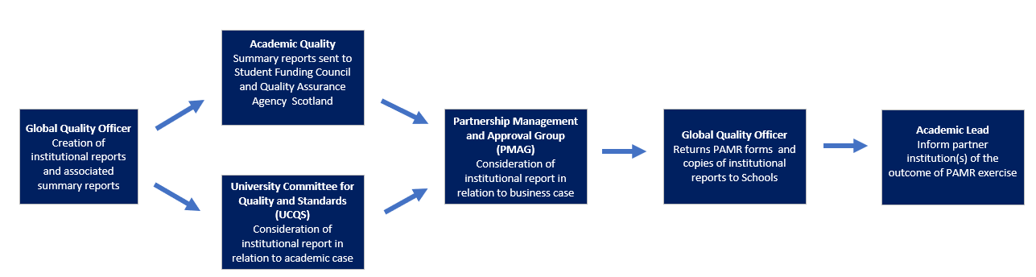
*Role descriptors in the above diagram have been updated as follows:
Global Quality Officer: now Partnerships Support Manager
PMAG committee is no longer involved in this process

4.2 A summary of key issues and good practice, in relation to the academic case, arising from PAMR will be included in the annual report to the University Committee for Quality and Standards (UCQS). The report will focus on overarching issues of strategic concern in relation to the University’s values and objectives or of significant concern for academic standards and quality.

4.3 A summary of the institutional report in relation to the academic case will also be provided to external bodies, including the Student Funding Council (SFC) and Quality Assurance Agency Scotland (QAAS).

4.4 Once approval of the annual reports has been granted by UCQS, feedback in relation to individual academic partnerships will be provided by Academic Quality to the Academic Leads and Associate Executive Dean (Academic Quality) via email. Academic Leads are responsible for communicating the outcome of the PAMR exercise to representatives from the partner institution, via email.

4.5 The Partnerships Support Manager will share the approved annual reports with all Academic Leads, Associate Executive Deans (Academic Quality), Associate Executive Deans (International), Associate Executive Deans (Education and Student Life), Associate Deans and the Deputy Principal (Education and Student Life), via email, to ensure the outcome of the exercise is clearly communicated. This concludes the Partner Annual Monitoring and Review process.

5. References and Associated Documents

5.1 Quality Assurance Agency Scotland:
UK Quality Code
UK Quality Code, Partnerships: Advice and Guidance

5.2 Associated Documents and Useful Links:
Heriot Watt University Ordinances
Partner Annual Monitoring and Review Form
Quality Assurance Hub SharePoint (Internal Only)
Appendix 1 Glossary

Term | Definition
Academic Case | Assurance that threshold academic standards are, as a minimum, maintained for academic partnerships.
Academic Lead | Appointed member of staff responsible for the implementation of the policies, procedures and decisions of the Collaborative Board of Studies.
Academic Partnership | An arrangement between two or more organisations to deliver aspects of teaching, learning, assessment and student support.
Delivery Partner / Approved Learning Partner | Partnerships where a Heriot-Watt University owned programme, or an aspect of a Heriot-Watt University programme, is delivered via another institution.
Business Case | Assurance of the financial viability of an academic partnership.
Collaborative Board of Studies | Recognised body or group of staff responsible for the management and administration of a programme/discipline delivered in partnership.
Enhancement | The process by which higher education providers systemically improve the quality of provision and the ways in which students’ learning is supported.
Joint Collaborative Partner | An institution or group of institutions which work together to jointly develop, manage and deliver a bespoke programme.
Lead Institution | Institution nominated to lead on the administration of the programme/discipline as set out within the terms of the legal agreement.
Partner Institution | The provider delivering aspects of teaching, learning, assessment or student support under delegated authority of the awarding organisation.
Partnership | An arrangement between two or more organisations to deliver aspects of teaching, learning, assessment and student support.
Student Experience | Encompasses all aspects of the students’ experience of studying their course, and their experience of any other resources, support, facilities and opportunities that the provider makes available to support students’ learning.
Teach Out | An arrangement by which institutions fulfil their educational and contractual obligations to provide current students with the opportunity to complete their programme of study when a partnership/programme ends.

APPENDIX 2 Partner Annual Monitoring and Review Process Flow Diagram

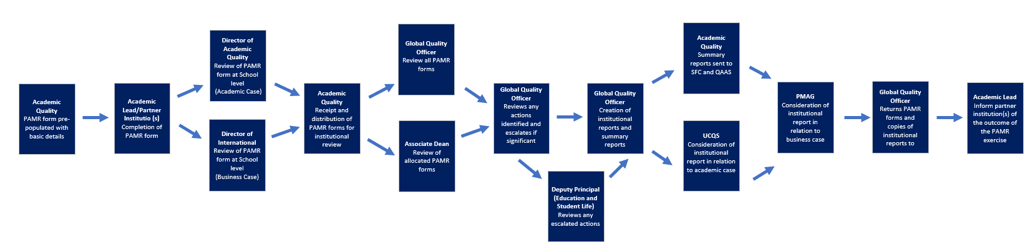
*Role descriptors in the above diagram have been updated as follows:
Director of Academic Quality: now Associate Executive Dean (Academic Quality)
Director of International: now Associate Executive Dean (International)
Global Quality Officer: now Partnerships Support Manager
PMAG committee is no longer involved in this process

APPENDIX 3 Roles and Responsibilities for Partner Annual Monitoring and Review

Role | Responsibility
Partnership Support Manager | - To co-ordinate the distribution, collection and institutional review of PAMR forms.  - To review all PAMR forms from an institutional quality assurance perspective with the purpose of identifying common School-level or University-level issues and highlighting areas of good practice.  - To determine whether any actions from individual PAMR reports require to be escalated to the Deputy Principal (Education and Student Life) in conjunction with the Quality and Academic Partnerships Manager.  - To produce institutional reports for submission to the University Committee for Quality and Standards (UCQS), Quality Assurance Agency Scotland (QAAS) and the Student Funding Council (SFC).  - To return feedback on individual academic partnerships to Academic Leads and Associate Executive Deans (Academic Quality).  - To share the approved annual reports with all Academic Leads, Associate Executive Deans (Academic Quality), Associate Executive Deans (International), Associate Executive Deans (Education and Student Life), Associate Deans and the Deputy Principal (Education and Student Life).
Academic Lead | - To reflect on the previous academic year regarding areas of good practice and areas for enhancement with the partner institution.  - To consult Heriot-Watt University colleagues (e.g. teaching staff, professional services) regarding the operation of the partnership.  - To complete the PAMR form in a timely and comprehensive manner, in collaboration with the partner institution.  - To communicate any feedback from the PAMR exercise to the partner institution.
Partner Institution | - To reflect on the previous academic year regarding areas of good practice and areas for improvement with the Heriot-Watt University Academic Lead.  - To consult colleagues (e.g. teaching staff, professional services) regarding the operation of the partnership.  - To complete the PAMR form in a timely and comprehensive manner, in collaboration with the Heriot-Watt University Academic Lead.
Associate Executive Dean (Academic Quality) | - To review all School PAMR forms to ensure responses provided are sufficiently detailed and, where necessary, request further information from the Academic Lead / Partner Institution.  - To ensure sufficient action plans have been put in place, where issues have been identified.  - To identify any common themes and good practice regarding the operation of partnerships across the School.  - To return PAMR forms to Academic Quality by the specified deadline.
Associate Executive Dean (International) | - To review all School PAMR forms from a business case perspective.  - To identify any potential areas for growth or expansion.
Associate Dean | - To review allocations of PAMR forms, from an institutional perspective, to:  - Determine whether proper engagement in the process has been demonstrated, with appropriate monitoring and review having taken place.  - Highlight if any issues need referred back to the School or escalated to the Deputy Principal (Education and Student Life).  - To summarise the findings of their review on form provided.
Deputy Principal (Education and Student Life) | - To review any PAMR forms which have been escalated by the Partnerships Support Manager.  - To determine whether any further action is necessary to address issues highlighted in escalated reports.  - To determine the most appropriate form of action, where necessary.

APPENDIX 4: Partner Annual Monitoring and Review Timeline

Month | Action
January - February | - Academic Quality pre-populates PAMR forms with basic details  - Academic Quality distributes forms to Academic Leads
February - May | - Academic Lead and partner institution(s) complete PAMR form  - Associate Executive Dean (International) reviews PAMR forms  - Associate Executive Dean (Academic Quality) reviews PAMR forms  - Associate Executive Dean (Academic Quality) submits PAMR forms to Academic Quality by the last Friday in May
June | - Academic Quality distributes PAMR forms to Associate Deans  - Associate Deans review PAMR forms by mid-June  - Partnerships Support Manager reviews PAMR forms by mid-June
June – August | - Partnerships Support Manager escalates any significant issues to Deputy Principal (Education and Student Life), if appropriate.  - Deputy Principal (Education and Student Life) reviews any escalated reports and determines if any further action is required.  - Partnerships Support Manager writes an institutional report in relation to the academic case for the University Committee for Quality and Standards (UCQS).  - Global Quality Officer writes a summary report, in relation to the academic case, for the Student Funding Council and Quality Assurance Agency Scotland
September – October | - Partnerships Support Manager (or Academic Quality representative) presents the institutional report in relation to the academic case to the University Committee for Quality and Standards (UCQS) for consideration and approval.  - Partnerships Support Manager returns PAMR forms and any feedback to Associate Executive Deans (Academic Quality) and Academic Leads  - Academic Lead provides feedback to partner institution(s) via email.  - Partnerships Support Manager shares the approved institutional annual reports with all Academic Leads, Associate Executive Deans (Academic Quality), Associate Executive Deans (International), Associate Executive Deans (Education and Student Life), Associate Deans and the Deputy Principal (Education and Student Life).

APPENDIX 5: Completion of a Partner Annual Monitoring and Review (PAMR) Form

Completion of a Partner Annual Monitoring and Review (PAMR) Form
Best Practice Guide

Purpose

To provide a ‘best practice’ guide on the completion of a Partner Annual Monitoring and Review (PAMR) form.

1. Introduction

1.1 Partner Annual Monitoring and Review forms part of the University’s wider Annual Monitoring Review process, aiming primarily to monitor and review the academic quality and standards of existing partnerships.

    - Partner Annual Monitoring and Review forms should be completed by the Academic Lead at Heriot-Watt University in collaboration with representatives from the partner institution(s). Partnership teams should jointly reflect on the previous academic year and refer to minutes from Collaborative Board of Studies meetings, where applicable, to inform responses provided. Teaching and professional services staff, involved with the operation or delivery of the partnership, should be consulted to ensure all areas of the student lifecycle are considered.

1.3 Academic Quality recommends that, where possible, a virtual meeting is held between the Academic Lead at Heriot-Watt University and representatives from the partner institution(s) to discuss and complete the PAMR exercise. The PAMR form should be shared with both parties, before the meeting, to allow prior consideration and to ensure focussed and open discussion during the meeting.

1.4 Consideration should be given to the following points when providing answers to questions posed:

- Balance
Answers should highlight areas for enhancement and reflect areas of best practice to ensure these can be shared at an institutional level.
- Complete
Answers should be provided for every question on the form. If a question is not applicable, appropriate justification should be provided.
- Detailed
Answers should be adequately descriptive and comprehensive to enable comparisons to be made both at School and institutional level. Analysis / commentary of data should be provided and justification for / against actions should be clearly stated.
- Timely
Answers should refer to the reporting period only. PAMR is a retrospective activity and thus information relating to the current academic year is not applicable for inclusion (however it is noted that in some instances reference to the current academic year is necessary and justified). When referencing trends, comparisons to previous years should be provided.

1.5 Examples of satisfactory / unsatisfactory answers are provided below for illustrative purposes only.

Example 1: Please provide commentary on trends in student recruitment and admissions over the last three years, including any significant changes in terms of demand in country if applicable, admissions processes, entry qualifications and student profile data. Are the numbers in line with expectations or contractual numbers / agreed quota? What factors contributed to any differences and how will they be addressed?



Limited information provided. Significance of deviation from student quota unknown.
Reason for programme being undesirable not provided.
No actions listed. Please provide actions for any issues reported.
Clear overview of actions provided
Analysis of trends in data provided
Supporting data given to provide context to answer.
Data provided to show context
Satisfactory | Unsatisfactory
The number of applications received has declined significantly (approx. 80%) over the past three years, with student enrolment figures now below the agreed quota of 50 students per annum.  General engineering is proving less popular in Example Country as students seek specialisms in the field of Robotics and Sensor Imaging which are viewed as more desirable by employers. Furthermore, students are seeking programmes with industry placements which they perceive as offering a more cohesive learning approach.  The partnership team has agreed to the following actions in an attempt to increase student recruitment:  - Review programme content, based on feedback from students and industry advisory panels  - Consult Example institution(s) marketing team to review promotional materials  - Increase School visits/open days to promote the programme and partnership | The number of applications received has declined over the past three years and student enrolment figures are below quota.  The programme is no longer desirable by students in Example Country which explains the lack of interest.

Example 2: Please provide commentary on trends in student continuation, progression between levels and completion over the last 2 years and reflect on the success of any initiatives to support retention, progression and completion. Please also provide commentary on student degree outcomes (by degree classification) and an explanation of any high failure rates (>10%).

No interpretation of the data provided.
Lack of clarity on whether any action is required in this area as no analysis or trend commentary provided.
Justification provided that no actions necessary
Analysis of trends in data provided
Supporting data given to provide context to answer.
Data provided to show context
Satisfactory | Unsatisfactory
Degree classifications are as follows 1st (25%), 2:1 (40%), 2:2 (20%), 3rd (10%) and ordinary (5%). There were no failures for the reporting period.  Degree classification figures have remained steady across the past three years and the spread of classifications was positively commented on by the External Examiner. Classifications are in line with other programmes within the discipline and other institutions for comparative programmes.  The partnership team deemed that degree classifications are acceptable and no actions required on this point. | Degree classifications are as follows 1st (25%), 2:1 (40%), 2:2 (20%), 3rd (10%) and ordinary (5%). There were no failures for the reporting period.

Example 3: Please comment on whether academic staff resources both at partner and HWU are adequate for the effective delivery and operation of the programme. Is any additional investment necessary in this area?

Lack of clarity on action implemented. Whilst recruitment may be the responsibility of the partner institution, a lack of teaching expertise raises concerns regarding the quality/standards of the academic partnership and requires addressing.

Please refrain from answering ‘no issues’ to questions posed. Instead, please highlight areas of good practice or provide reasoning as to why points are deemed adequate.
Context not provided and no interpretation of data.
Justification provided that no actions are required at HWU and appropriate actions underway at partner institution.
Commentary of trends in data provided
Supporting data given to provide context to answer.
Data provided to show context
Satisfactory | Unsatisfactory
Due to retirement, three members of academic staff have now left Example University resulting in a significant loss of expertise to the department. Casual workers were hired to provide assistance for courses in the January semester, however, a more permanent solution is required to ensure effective leadership and the quality and standards of the programme. Approval has been sought to replace these positions and interviews are underway. New members of staff will be in place for the beginning of the next academic year and programme lead will ensure any new members of staff are adequately briefed on the programme and importance of this partnership.  There have been no changes to the programme team at Heriot Watt University. Declining student numbers on the programme, and across the discipline, have meant that academic staffing resources remain satisfactory for the effective delivery and operation of the programme. Excellent support has been received from PhD students, as approved demonstrators, which has benefitted both course teams and students. Academic staff resources will remain under continual review. | Three staff left Example University in the last reporting period and will need replaced, however, this is an issue for the partner institution.  Resources at Heriot Watt University are fine and no issues to report.

Example 4: Please comment on how significant issues raised by students are addressed and how outcomes are reported back to students.

Unclear whether action is required in this area due to the lack of information provided in response.
Lack of clarity provided in answer. Please ensure responses have sufficient detail to answer the question posed.
Justification provided that no actions are required.
Suitable commentary provided
Information given to provide context to answer.
Data provided to show context
Satisfactory | Unsatisfactory
Issues raised by students are openly discussed with both staff and student representatives at student staff liaison meetings to determine the most appropriate solution. Advice is sought from other departments and senior management if necessary. An action plan is documented and communicated to students by student representatives and also verbally by staff at townhall departmental meetings. No issues have been reported by students in terms of communicating the outcomes of student feedback mechanisms and the partnership team is satisfied that current mechanisms are working well. | Issues raised by students are discussed and appropriate solutions put in place.  Outcomes are always communicated to students so no actions required.

